ASSIGNMENT 9
Hybrid WAN (SD-WAN)
Shreya Panchal
Topic: Introduction to SD-WAN, Key Benefits of SD-WAN

Theory Overview

1. What is Hybrid WAN?
A Hybrid WAN is an architecture that connects geographically dispersed branch offices to a corporate headquarters or data center using a combination of different physical connection types. Instead of relying solely on expensive, private MPLS circuits, a hybrid network blends private lines with low-cost commercial paths like business broadband, internet fiber, and LTE/5G cellular networks.

2. What is SD-WAN (Software-Defined Wide Area Network)?
SD-WAN is an evolution of Hybrid WAN. It decouples the network control plane from the underlying physical hardware, moving management into a centralized, software-driven dashboard. Instead of configuring individual routers line-by-line, administrators define high-level traffic steering and security rules. The SD-WAN controller then automatically and dynamically directs applications along the fastest, most reliable path available across the hybrid connections.

Tasks & Answers

Task 1: Traditional WAN vs. SD-WAN Comparison Table
Question: Create a comparison table listing at least 5 key differences between traditional WAN and SD-WAN, focusing on how data is routed, managed, and secured.
Answer:
Feature | Traditional WAN | SD-WAN (Software-Defined WAN)
Control & Management | Decentralized: Each router must be configured manually, line-by-line, via CLI at every physical location. | Centralized: Managed entirely through a unified software orchestrator or cloud dashboard.
Data Routing Method | Static / Metric-Driven: Routes packets purely based on fixed Layer 3 routing metrics (like OSPF or BGP costs). | Application-Aware: Identifies the type of traffic (e.g., WhatsApp vs. File backup) and routes dynamically based on real-time link health.
Circuit Utilization | Active-Passive: One link carries all traffic (e.g., MPLS) while backup broadband links sit idle until a complete circuit failure occurs. | Active-Active Load Balancing: Smoothly uses multiple connections (MPLS, Broadband, LTE) simultaneously to maximize total bandwidth.
Security Execution | Per-Device Configuration: Requires adding separate hardware firewalls or complex manual VPN configurations at every branch office. | Built-in / Native Security: Automatically deploys end-to-end encrypted IPsec tunnels across all transports with central firewall policies.
Cloud Application Path | Backhauling / Tromboning: Forces cloud traffic (like Office 365 or AWS) through corporate headquarters before sending it to the Internet, slowing down performance. | Direct Internet Access (DIA): Safely identifies and offloads trusted cloud traffic locally at the branch level, bypassing corporate HQ.

Task 2: SD-WAN Architecture Diagram
Question: Draw a simple network diagram (on paper or using a tool like draw.io) showing how SD-WAN connects multiple branch offices to cloud apps (like Office 365 or AWS) and the main data center. Label the SD-WAN controllers, edges, and at least two types of WAN links (e.g., MPLS, broadband).
Answer:
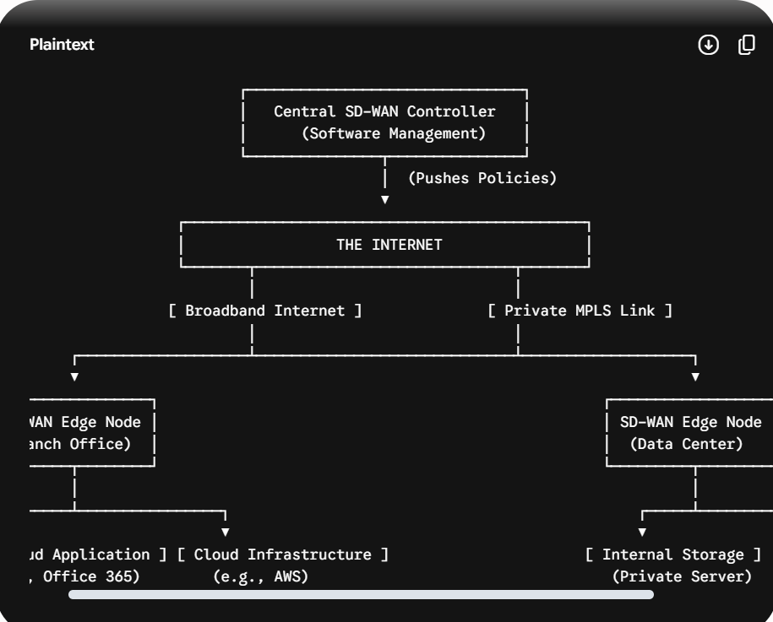

Task 3: App Optimization Scenario (Zomato / Real-Time Data)
Question: Pick any app you use daily (like WhatsApp, Zomato, or Instagram) and write a short scenario explaining how SD-WAN could improve user experience for that app when used across multiple cities in India. Hint: Think about speed, reliability, and security when users access the app from different locations.
Answer:
Let's look at Zomato, which processes thousands of live food orders, online payments, and driver GPS coordinates every minute across major hubs like Ahmedabad, Mumbai, and Bangalore. If Zomato uses a traditional WAN architecture, remote regional offices or support centers must send customer support queries, restaurant order logs, and transaction requests all the way back to their primary data center in Mumbai before interacting with cloud servers. During peak dinner hours, this old system bottlenecks, causing delays in order updates, payment timeouts, or app lag.
Upgrading the enterprise backend network to SD-WAN dramatically enhances the user experience. If an intense rainstorm hits Mumbai and degrades local broadband connectivity, the SD-WAN system instantly reroutes live order coordinates over a secondary high-speed fiber line or 5G backup link within milliseconds. Customer support centers in Ahmedabad can interact directly with cloud hosting servers via Direct Internet Access rather than routing through Mumbai, accelerating update processing times. This ensures the app is highly secure, runs smoothly without service dropouts, and coordinates restaurant dispatch data accurately.

Task 4: Three Key Corporate Benefits of SD-WAN
Question: List and explain three key benefits of SD-WAN for a company with offices in Ahmedabad, Mumbai, and Bangalore. For each benefit, give a real-world example of how it would help employees or customers.
Answer:
1. Dynamic Application-Aware Routing
Explanation: The network automatically identifies the type of application generating data traffic and calculates the most optimal path based on real-time link parameters like latency, packet loss, and jitter.
Real-World Example: During an internal corporate video conference between teams in Ahmedabad and Bangalore, the SD-WAN system notices a performance drop on the standard broadband line. It seamlessly shifts the video traffic to a high-quality MPLS line while routing less-critical background data (like email syncs) onto a cheaper public internet connection, preventing call dropouts or video freezing for employees.
2. Cost Reduction via Hybrid Link Deployment
Explanation: Instead of buying expensive, high-bandwidth private MPLS lines for every single corporate location, companies can purchase standard, affordable commercial broadband fiber and combine them safely using software control.
Real-World Example: The Mumbai headquarters can scale down its recurring monthly expenses by shrinking its legacy MPLS bandwidth size and handling routine traffic via high-speed, cheaper commercial broadband connections, significantly reducing infrastructure costs without losing connection stability.
3. Zero-Touch Provisioning (ZTP) and Centralized Control
Explanation: Deploying hardware to new office locations does not require sending a highly trained network engineer onsite. Once a base device is connected to power and the internet at a remote branch, it automatically downloads its full routing configuration and security policies from the central cloud dashboard.
Real-World Example: If the enterprise opens a new regional branch office in Ahmedabad, the IT department can ship an unconfigured SD-WAN edge device directly to the office. A local employee simply plugs it in, and the device automatically provisions itself within minutes, getting the office online rapidly.

